Digital research documentation

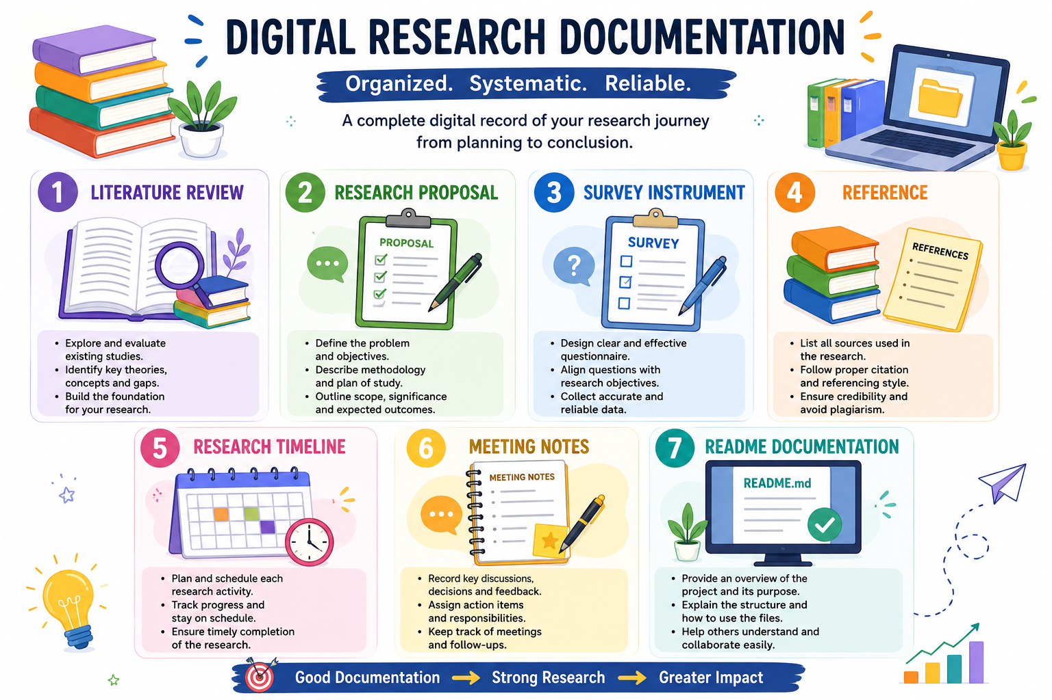
LITERATURE REVIEW
A literature review is an important part of a research proposal
That examines existing studies and information related gaps, limitations, and unanswered questions in previous research. It may include information from research papers, academic journals, books, reports, and reliable online sources . By comparing and analyzing previous studies, the researcher can develop a strong foundation for the current research. A well-written literature review also helps support the research problem, objectives, and methodology. Overall, it provides a clear understanding of existing knowledge and shows how the proposed research can contribute something ne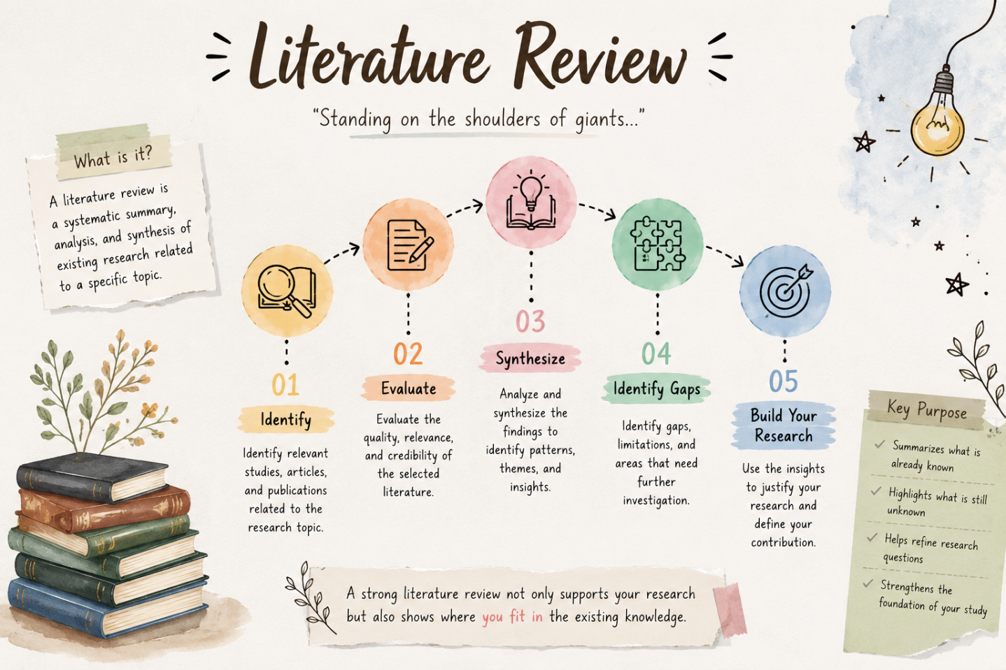l

^{RESEARCH PROPOSAL}

A research proposal is a detailed plan that describes a proposed research study. 🔍 It explains what the researcher wants to study, why the topic is important, and how the research will be carried out.
It includes the research objectives and research questions that guide the study.
A literature review presents previous studies and helps identify gaps in existing knowledge.
The research methodology explains the methods used to collect and analyze data.
The significance of the study describes how the research can contribute to knowledge or society
A timeline shows the different stages of the research process.
Finally, references provide the sources used to support the research .Overall, a research proposal provides a clear roadmap for conducting meaningful and systematic research
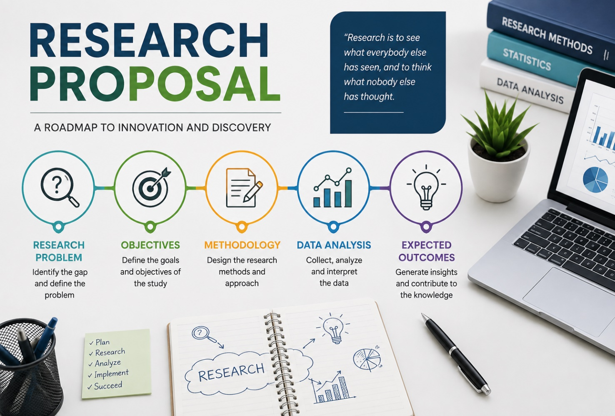📐

Survey Instrument

surveyors to measure and determine distances , angles , directions , elevations , and positions of different points on the ground. They are widely used in land surveying, mapping , road construction , building construction , and other civil engineering works. Common survey instruments include the chain and tape for measuring distances, the compass for finding directions and bearings, the level for determining differences in elevation, and the theodolite for measuring horizontal and vertical angles. A plane table is used for field plotting and preparing maps directly at the survey site. Modern instruments such as the total station can measure angles and distances electronically and store survey data . GPS/GNSS is used to determine the accurate position and coordinates of points using satellite signals . Proper handling and careful use of these instruments are necessary to obtain accurate and reliable results .Therefore, survey instruments play an important role in making surveying work easy, fast, and accurate.
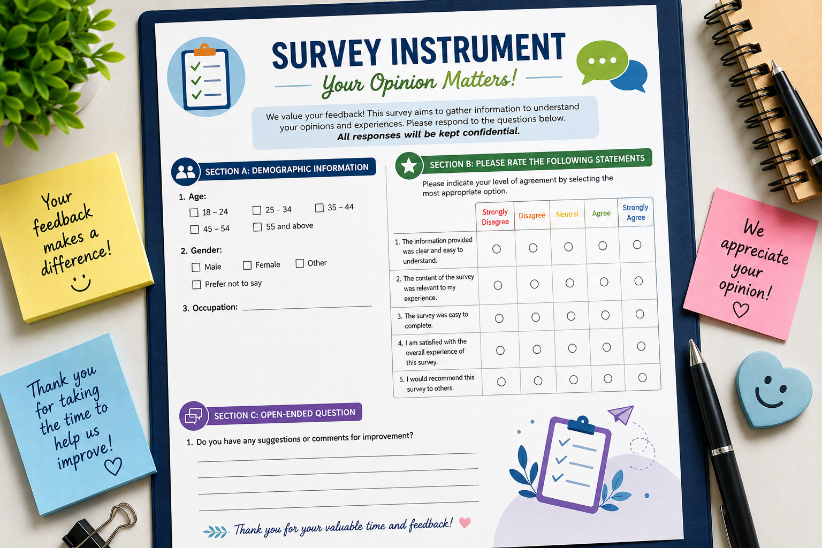
REFERENCE

References are an essential part of a research proposal because they provide information . Reference used to support the research. They can include books , academic journals , research articles , websites , reports , and other reliable sources. References help the researcher build a strong foundation for the study and show that the research is based on existing knowledge and evidence.
Proper referencing gives credit to the original authors and prevents plagiarism. It also allows readers to verify the information and explore the topic further. Using a consistent referencing style, such as APA, MLA, or Harvard, makes the research professional and easy to understand. Therefore, accurate and well-organized references improve the quality, reliability, and credibility of a research proposal.
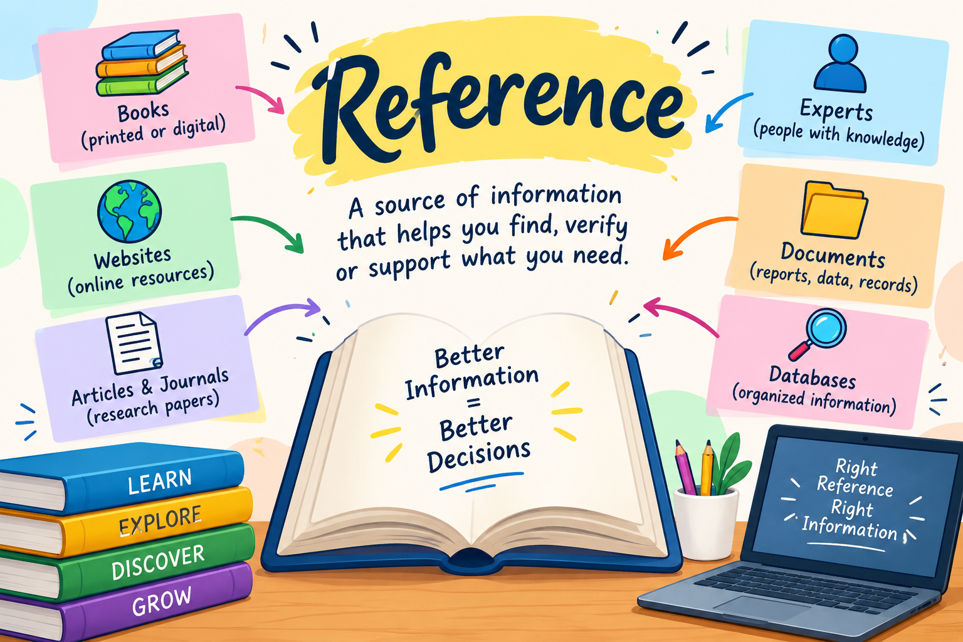

RESEARCH TIMELINE
The research timeline provides a structured plan for completing the study within the proposed period. The research will begin with the identification of the research problem and development of research objectives, followed by a review of relevant literature and preparation of the research methodology. After designing and validating the survey instrument, data will be collected from the selected participants. The collected data will then be organized, analyzed, and interpreted to identify key findings. Finally, the results will be discussed, conclusions and recommendations will be developed, and the research report will be completed and submitted. This timeline helps ensure that each stage of the research is completed systematically and within the planned timeframe.

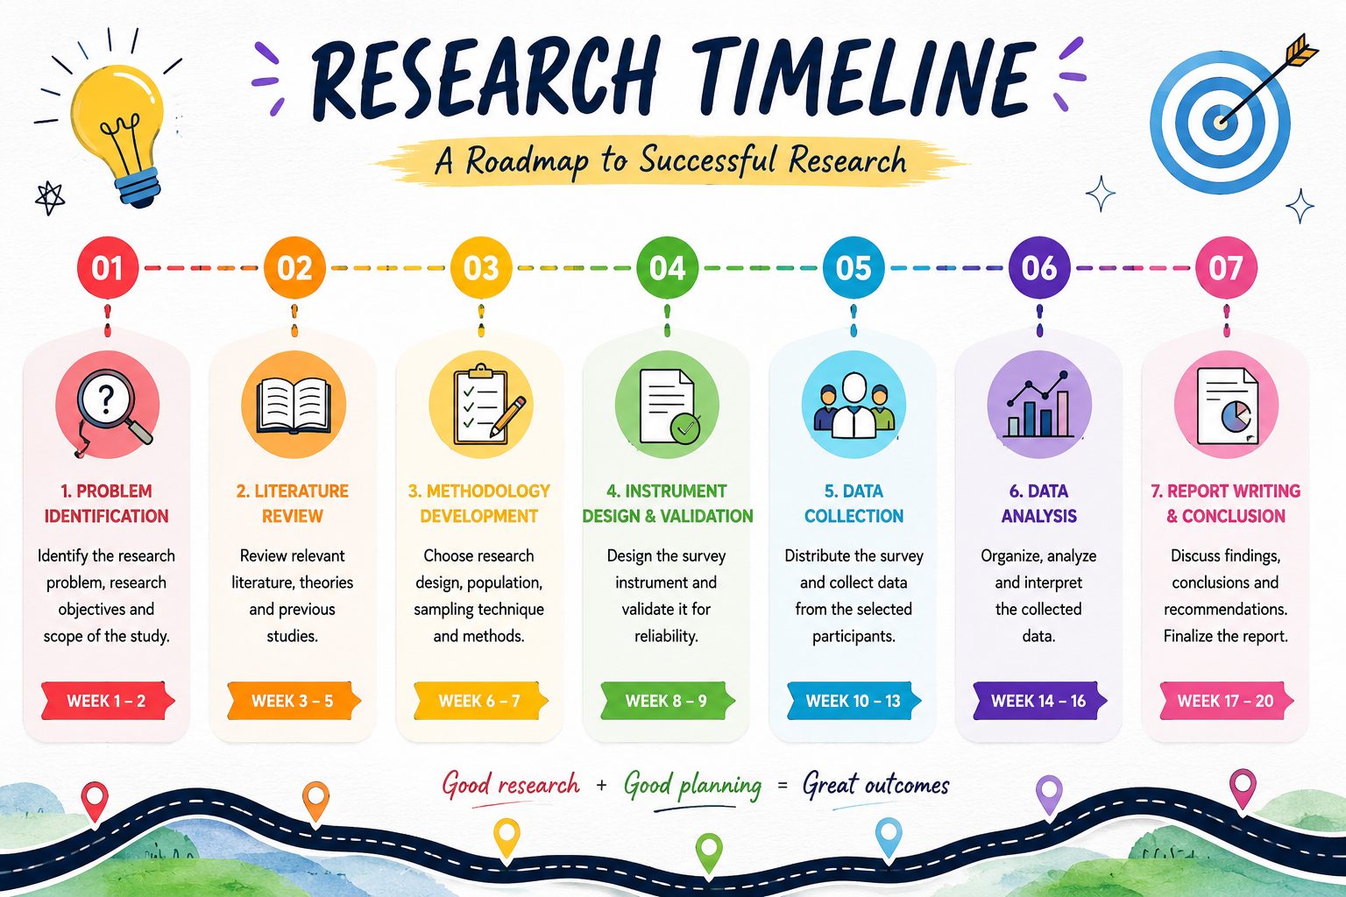

MEETING NOTES
The meeting notes provide a clear record of the key discussions, decisions, and action points agreed upon during the research meetings. Each meeting focuses on reviewing the progress of the research, discussing challenges, sharing suggestions, and planning the next steps. Important feedback from the supervisor or research team is documented to ensure that necessary improvements are made to the research design, methodology, survey instrument, data collection, and analysis. These notes help maintain an organized record of the research process and ensure that all tasks are timeline.
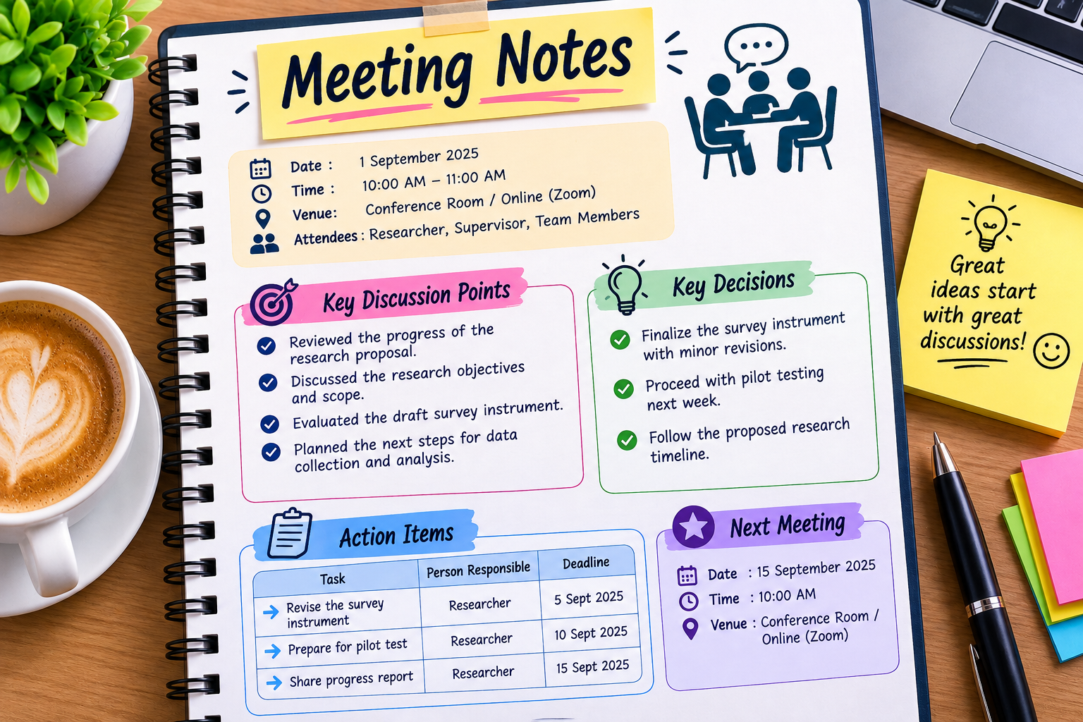

README DOCUMENTATION

Digital Research Documentation

About
This project organizes important research documents in one digital location.

Contents
- Literature Review
- Research proposal
- Survey Instrument
- Reference
- Research Timeline
- Meeting Notes

Purpose
The purpose is to keep the research process organized, clear, and easy to manage.

Conclusion
Digital documentation helps track research progress and maintain all important research materials in an organized way.
